**Continuous Delivery:**

1. we can code and build using **visual studio team service**
2. then move the code to **slots** to test using **deployment slots**
3. And then **swap** to deploy

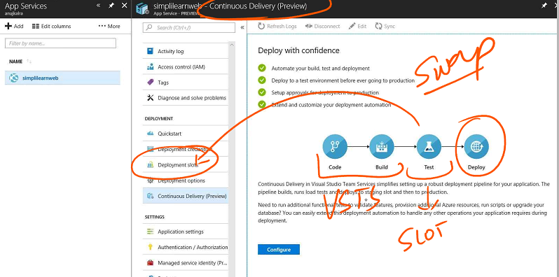

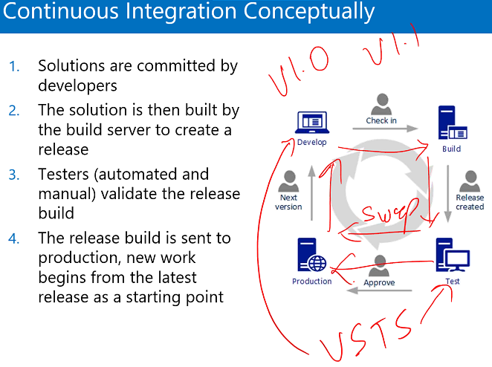

1. Continuous integration – code is frequently merged using automated build and test
2. Continuous delivery - code changes that are build and tested are automatically published to slots
3. Continuous deployment – code changes that pass CI and CD are automatically deployed to production

**DevTest Labs**

It’s a lab environment, cheaper, but performance is not that great especially for developers

